PID and Controls Report

UTA RACING

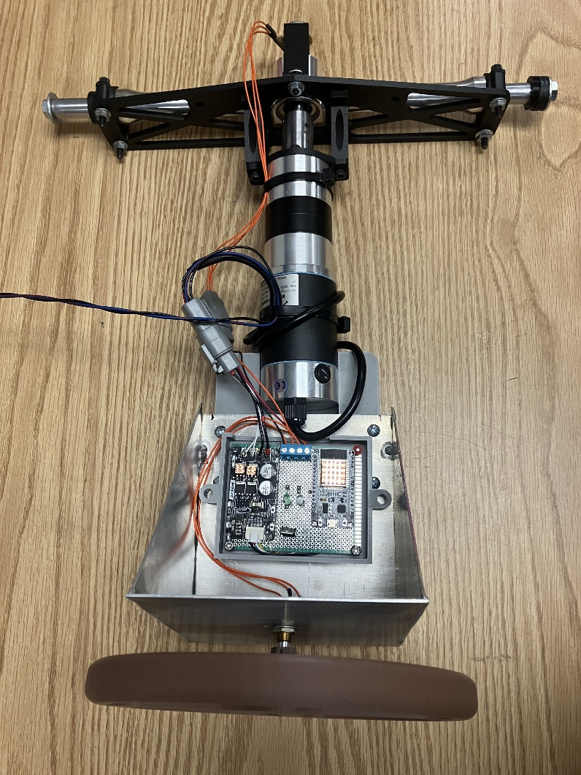

Osama Almasri
Samatar Samatar
Tayden Carter
George Kallam
Sarbagnya Bhattari
4/9/25
Turn Radius vs Steering Percentage
There is an equation that is derived from Dr. Woods data that relates the front turn radius to the rear steering percentage. The Four-Wheel Variable Counter Steering report has all the inputs (Turn Radius) and outputs (Percentage Rear Steer) and the equation that is formed from this table is shown with Y being the percentage rear steer and X being the turning radius.
$$Y= -50\tanh\left(0.1X-4.5\right)+50$$

In the Turn Radius report we were able to experimentally measure the Steering Wheel angle vs the Turn Radius for both left and right turns. By doing that, we have the following equations for the Left Turning Radius and the Right Turning Radius which is shown with X being the turning radius and $θ_{w}$being the Steering Wheel angle.

$X=2760{(θ_{w})}^{-1.222}$ $θ_{w}>0$ Left Turn

$X=2677{(θ_{w}*-1)}^{-1.147}$ $θ_{w}<0$ Right Turn

In the right turn equation, the degrees are multiplied by -1 in order to make the value positive and easier to read. The wheel angle is positive CCW from TDC and negative CW from TDC. In the code this logic is applied, and the percentage rear steer equation is turned into the following.

$Y= -50tanh⁡(0.1\left(2760{\left(θ_{w}\right)}^{-1.222}-4.5\right)+50$ $θ_{w}>0$ Left Turn

$Y= -50tanh⁡(0.1\left(2677{\left(θ_{w}*-1\right)}^{-1.147}-4.5\right)+50$ $θ_{w}<0$ Right Turn

The percentage rear steer is going to affect the rear potentiometer degree readings, in this project we are using the rear potentiometer for the sensor that measures the rear steering angle in degrees. The rear potentiometer has 270 degrees of motion making it 135 degrees each way, so the percentage is multiplied by the degrees of the specified turn therefore outputting the desired rear potentiometer angle and controlling the servo-steering rack to make the measured reach the desired. If the percentage of rear steer is 50% then the desired rear potentiometer angle is 67.5 degrees, and the servo will be powered to make the measured potentiometer value reach 67.5 degrees.

PID Tuning
Currently we are only using the Kp and Kd terms of the PID Controller and using the calculated desired rear potentiometer angle compared with the measured rear potentiometer angle. After testing and iteration the values of Kp = 0.16 and Kd = 0.008 showed the measured rear potentiometer angle reaching steady state earlier than previously tested values.

Measured Rear Steer Percentage
In the Four-Wheel Counter Steering report from Dr. Woods there is a table of data that has the Turning Radius and the desired rear steering percentage, and those points were put on an excel plot. The control setup was then formatted to output the Turning Radius and the calculated Percentage rear steer from the above equation and the data was plotted alongside the previous points outputting the following plot.

